Leni Riefenstahl: Actress, Filmmaker Contributor to Nazi Mayhem
There is no doubt that Leni Riefenstahl was a very innovative and creative filmmaker. Riefenstahl believed she was creating documentaries, but she was simply a vehicle for the creation of Nazi propaganda. While some consider Riefenstahl a pioneer and genius, others see her as a devious contributor to Nazi mayhem. Although Riefenstahl cannot be questioned on her expertise in making films, she was a major source of Nazi propaganda. Whether or not she knew where her actions would take Germany, Riefenstahl is responsible for a work that made something very evil look appealing. She defends herself as having made a documentary. Many, on the other hand, believe that Triumph of the Will is far from a documentary. After all, the little bit of dialogue in the film is of Hitler and other high level Nazis giving speeches.
Before creating the films she is famous for, Leni Riefenstahl was a famous actress and dancer. She was favored between Hitler and many other high profile Nazis because of her filmmaking talent. She captured the Nazis in a certain light that proved to dazzle the German public. Her most famous work for the Nazis, Triumph of the Will, glorified a 1934 rally in Nuremberg. The filming techniques that Riefenstahl employed were considered to be very cutting edge for the era she worked in. She used tracks, lifts, and cranes to capture interesting and never-before seen angles. Riefenstahl pioneered many techniques used today in filmmaking in the 1930's. Watching scenes of military assembly in George Lucas' Star Wars bring about the eerie Riefenstahlian touch.
But unlike filmmakers of today, filming was especially difficult for Riefenstahl because the cameras she used were much heavier and more difficult to operate than those today. Another famous work of Riefenstahl's was Olympia, a documentary on the 1936 Olympic games held in Berlin. And while both films are considered classics almost 70 years later, Riefenstahl's reputation has been tainted after the Nazi Regime crumbled in the aftermath of WWII. Some Riefenstahl critics point out that she created propaganda for a regime that it held responsible for the deaths of millions of innocents. Riefenstahl defends herself by saying that she was never a member of the Nazi party; that she was simply trying to make a documentary film that would be more interesting than the rest.
And interesting they were, over half of the German population watched Riefenstahl's Triumph of the Will when it was released. When compared to the older, poorly made propaganda film the Nazis had temporarily released, Triumph of the Will triumphs as a masterpiece. It's sweeping views of marching Nazis gives the feel of power and determination. The Nazis appear organized and regal, marching proudly. Particularly interesting were the shots taken from tracks around Hitler and other top-tier Nazi officials. The combination of film technique and editing made it easy to imagine what it might have been like to hear Hitler give a speech to thousands of fanatic Nazis. After the war, Riefenstahl did not make any more films. In a documentary made interviewing her in the 1990's, she vehemently fights off allegations that she was socially involved with Hitler and Goebells during the height of the Nazi regime.
People tend to disagree on whether or not Triumph of the Will is a film of propaganda or a simple documentary. Riefenstahl herself claims that she was merely trying to make a film about the rally in Nuremberg. She says that she was assigned a job and believes that she captured the true essence of what it felt like to have attended the rally. She explains that while most propaganda films have a narrator, hers does not. And although it may have been true for the era when Riefenstahl worked for the Nazis, most good documentaries are narrated. Riefenstahl tries to create an image of herself as the passive observer; simply filming and editing an event that she did not really take part in. However, in the book Hinter den Kulissen des Reichsparteitag-Films, she explains that the rally was created for the film. The Nazis knew that Riefenstahl's film would reach millions upon millions of eyes, therefore they allowed her to set up the rally as she pleased; giving her some power in planning the rally would lead to a more effective film.
In discovering whether or not Triumph of the Will was a work of propaganda or documentary, it's important to decide for oneself the motivations and effects behind these two genres of films. Generally, a documentary is created for the effect of educating people about the facts behind a subject. A work of propaganda can be considered 'half' a documentary in that while it does aim to show people facts, it selectively chooses what it will and will not show with the intention of misleading an audience.
To Leni Riefenstahl, Triumph of the Will is a documentary. It is crystal clear that Riefenstahl was very talented and received what she believed was a priceless opportunity from Hitler. After Triumph of the Will and Olympia were released, Riefenstahl was a name that the entire world was acquainted with. And although her reputation was tarnished after WWII because of her relationship with the Nazis, her career flourished under the Nazis. Most people will never know what it's like to be personal friends with people of untouchable power. Riefenstahl is not one of these people. Before the Nazis seized power, Riefenstahl was a famed actress and dancer. But after the Nazis took power, she was making films and having dinner at a table with people who were on the brink of taking Europe over. It seems as though she enjoyed the admiration and distinction that being close to men in power brought her. Life couldn't have been better for Riefenstahl during the Nazi Regime. It was the most productive and memorable part of her life. To Leni Riefenstahl, her film was a documentary. She is showing the world the side of the Nazis she knows. She is showing the world power, prestige, and her feelings of accomplishment and pride. In Riefenstahl's eyes, she is showing the world a documentary about a Nazi rally in Nuremberg.
But Riefenstahl knows a very different Nazi Germany than most do. If Riefenstahl were in a concentration camp, her documentary would have probably looked a lot different. To face the facts is to understand that Riefenstahl had a very biased opinion on Hitler and the Nazis. And although very artful and creative, she passed her bias onto her film and fans. Had Riefenstahl truly created a documentary, she would have shown more than one side of the Nazi party. But Riefenstahl would have never created a film that illustrated all the death, deception, and manipulation used by the Nazis to seize power.
The way that Hitler is projected during the film is especially noteworthy. The audience is first shown romantic footage of the skies and clouds. In the midst of all this a plane is spotted flying through the German air. It's none other than Hitler descending upon Germany much like a heavenly god would descend from the skies. As the film progresses, it becomes evident that there is a clear distinction between the masses of people and Hitler. The crowds become faceless people while Hitler is portrayed as something of deity. Hitler is not simply one of the people; he stands on an ever-present pedestal.
Although the evidence seems quite strong that Riefenstahl was an enormous part of Nazi evil, those who side with Riefenstahl would elude to her other films in explaining that her works are documentary-like and unbiased. Leni's 1936 film Olympia has close-up segments of the African-American runner Jesse Owens. Riefenstahl knew that Hitler despised blacks and wished that that none were positively portrayed in the German made film. Contrary to Hitler and Goebells' wishes, Leni showed clips of the runner in her film.
Riefenstahl was an expert filmmaker, and although she tried to make what she refers to as 'documentaries,' the effects of some of the films were quite the opposite. While many Germans believed the Nazis to be saviors of a once fallen nation, Nazi contributions including conquering nations and killing innocent civilians. And while Riefenstahl claims she was merely fulfilling an artistic job, she indirectly contributed to Nazi evils through attracting more people to the party. All in all, Triumph of the Will is a bad work, but Leni Riefenstahl did an excellent job making it.
Works Cited & Linkography
http://womenshistory.about.com/library/bio/blbio_riefenstahl.htm - an in-depth site about the life and achievements of Leni Riefenstahl; hosted by about.com.
http://www..kamera.co.uk/features/leniriefenstahl.html - a British web site hosted by kamera.co.uk outlining Leni's life achievements; good and bad.
http://www.leni-riefenstahl.de/ - the official Leni Riefenstahl web site. It shows Leni Riefenstahl's life through her own eyes.
Riefenstahl, Leni. Leni Riefenstahl: A Memoir. Picador, USA; 1978.

http://marcuse.faculty.history.ucsb.edu/classes/33d/projects/naziwomen/LarryOnLeniMain.htm
Is Leni Riefenstahl’s Olympia Nazi propaganda – or the greatest film about sport ever made? Nicholas Barber takes a look.
By Nicholas Barber
10 August 2016
In Stephen Hopkin’s recent Jesse Owens biopic, Race, Owens (Stephan James) is about to compete in the 200m sprint in the 1936 Berlin Olympics, and Leni Riefenstahl (Carice van Houten) is about to film him, when Hitler’s propaganda minister, Joseph Goebbels, insists that the cameras are switched off. He doesn’t want the world to see Germany’s fittest young Übermenschen being left in the dust by an African-American. But Riefenstahl doesn’t listen. She is determined that her Olympic documentary will be a work of timeless truth and beauty, whether Hitler approves or not.
Is that really what happened? It’s true that Riefenstahl’s two-part documentary, Olympia, includes Owens’ victories over his Aryan competitors, and it’s true that it was acclaimed as a masterpiece that revolutionised the way sport was depicted on screen: in 1955, a mere decade after World War Two ended, a group of Hollywood directors chose it as one of the 10 best films ever made. But cinema historians still debate whether Riefenstahl was defying Goebbels and Hitler, 80 years ago this summer, or whether she was doing exactly what they wanted.
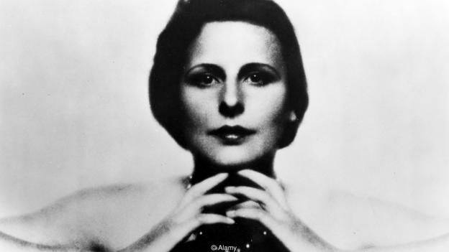
Leni Riefenstahl trained as a dancer and was an actor in several hit films of the 1920s and ‘30s before she became a director (Credit: Alamy)
There’s a lot less ambiguity about Riefenstahl’s previous film. Helene Bertha Amalie Riefenstahl’s most famous accomplishment is Triumph of the Will, a horribly gripping account of the Nazi Party’s 1934 Nuremberg rallies. The film is so dynamic, so compelling, so grand and ambitious, that it ranked at number 19 in a 2014 Sight & Sound magazine poll of cinema’s best documentaries. It is also, on the other hand, a monumental piece of Nazi propaganda. Opening with a caption trumpeting “German rebirth”, Triumph of the Will goes onto imply that Hitler is nothing less than the godlike saviour of Germany. Not that Riefenstahl ever admitted that this was what she intended. “Everything in it is true,” she later protested. “And it contains no tendentious commentary at all. It is history. A pure historical film.
‘Total control’
The Führer was so delighted by this “pure historical film” that he gave Riefenstahl an even bigger, more expensive commission. Olympia Part One: Festival of the Nations and Olympia Part Two: Festival of Beauty wouldn’t just chronicle Berlin’s Olympics, they would be a meditation on everything the Games stood for, and everything Germany could achieve. “Olympia broke the mould of Olympic films in many ways,” writes David Goldblatt in his new book about the Olympics, The Games. “First, Riefenstahl had a degree of active support from the organizers... that no other film-maker had acquired. She had total access and total control, and an immeasurably large crew and budget. Second, in terms of technological and cinematic sophistication, there was no comparison.”
There are no delays and no disappointments, and no moments which aren’t entertaining
Part One begins with a mystical glide through the smoke-wreathed ruins and statues of ancient Greece. The statues then metamorphose into naked athletes and dancers – one of whom is Riefenstahl herself – and the film floats through time and space until it reaches the lighting of the Olympic cauldron in Berlin – the torch relay was invented for the 1936 Games. After the colossal opening ceremony, Olympia speeds through the events in and out of the stadium, flitting from highlight to spectacular highlight. The momentum never flags. The enthusiastic commentary and Herbert Windt’s stirring music never stop. In the sunlit idyll which Riefensthal creates for the viewer, the most logistically complicated pageants – whether they are political rallies or sporting jamborees – move like clockwork, with no delays and no disappointments, and no moments which aren’t entertaining. Alfred Hitchcock once said, “What is drama but life with the dull bits cut out?” And on those terms, Riefensthal can stand alongside any dramatist ever to work in cinema.
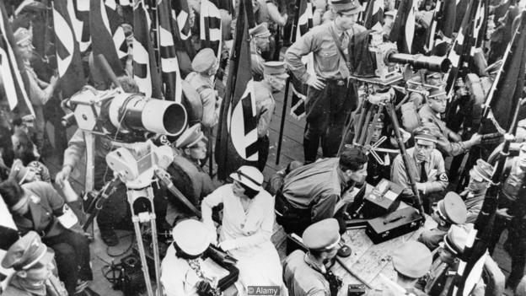
Riefenstahl had impressed Hitler with Triumph of the Will, a documentary of the 1934 Nazi Party Congress in Nuremberg (Credit: Alamy)
The film’s one glaring flaw is that she isn’t very interested in the Games’ competitive element. She doesn’t build much tension over who is going to win any of the events. Her only concern is to make them all uniquely cinematic, via slow-motion sequences, tracking shots, an astonishing number of different camera angles, and some extreme close-ups which were filmed afterwards and then spliced into the competition footage. This radical aesthetic approach culminates in a mesmeric high-diving montage shot by Hans Ertl. What begins as a straightforward record of the competitors’ dives becomes more abstract and ecstatic until it is more like an aerial ballet, or a firework display. Riefenstahl even runs one segment backwards, so that a diver soars out of the water and into the air.
Knowing what we do about Nazi Germany, the film’s obsession with race is troubling
Whenever you start to be hypnotised by Olympia, though, you are jolted back to reality by a shot of Hitler, up in the stands, clapping and cheering when the Germans are doing well, drumming his fingers on his uniformed knee when they aren’t. These candid interludes, say Riefenstahl’s detractors, were a concerted ploy to humanise a brutal dictator. But it’s an accusation that’s impossible to prove. To the untrained eye, it just looks as if Hitler is being Hitler.
Besides, in Riefenstahl’s defence, her representation of Owens is entirely positive. Repeatedly described by the commentator as “the fastest man in the world”, Owens is shown not just winning four gold medals, but beaming at the camera afterwards. No other athlete in the film makes anywhere near as much of an impression. Nor is Owens the only black competitor to feature in Olympia. Knowing what we do about Nazi Germany, the film’s obsession with race is troubling: the commentator notes that the line-up in the 800-metre final has “two black runners against the strongest of the white race”. But this fixation has its subversive aspect. The “black runners” – John Woodruff and Phil Edwards – finish the 800-metres in first and third place. It’s hard to see how this sequence could have served the Nazi cause.
Game theory
As much as Olympia glorifies Germany, it can just as easily be read as a celebration of multi-racial America. Again and again, Riefenstahl focuses on a US victory. And on two separate occasions, she superimposes a fluttering Stars and Stripes on a shot of a handsome, smiling, American medal-winner. She may have wanted to impress Hitler, but she also had her eye on a career in Hollywood.
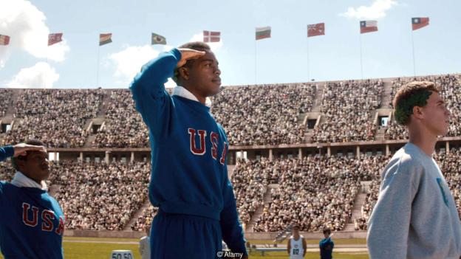
Stephen Hopkins’ 2016 film race dramatises moments from the 1936 Berlin Games – including Jesse Owens’ victories (Credit: Alamy)
Olympia’s most Nazi-like attributes are those which are intrinsic to the Olympics
She didn’t get one. Just after Riefenstahl arrived in New York in November 1938 to promote Olympia, news of the Kristallnacht pogroms reached the US: more than 1,000 synagogues throughout the Reich had been burnt in one night, thousands of Jewish businesses had been vandalised, and 30,000 Jews had been taken to concentration camps. After Riefenstahl declared to the American press that she didn’t believe these reports, no studio boss in Hollywood would see her – the exception being Walt Disney. She returned to Germany, where she started work on an epic drama, Lowlands, using Gypsy extras who, it was claimed in a 2002 lawsuit, were sent to Auschwitz once filming was finished. (The case was dropped when Riefenstahl retracted a public statement claiming all the extras had survived the War.)
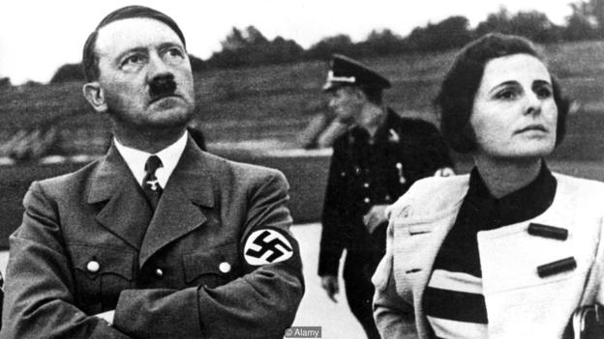
Riefenstahl’s close ties to the National Socialists – and Hitler in particular – haunted her for the rest of the life, but she remained adamant she was no Nazi (Credit: Alamy)
Riefenstahl’s long life after 1945 was a strange one. She wasn’t convicted of being a Nazi, and she regularly sued anyone who said otherwise, but she couldn’t wash off the stink of Hitler. Lauded as one of the greatest directors ever to pick up a megaphone, she only released one more film, Underwater Impressions, in 2002.. She died a year later, aged 101.
Riefenstahl’s biographers have since come to agree that she had a closer relationship with Goebbels and Hitler than she liked to claim. But it would be wrong to decry Olympia as a fundamentally Nazi film. It isn’t. In fact, its most Nazi-like attributes are those which are intrinsic to the Olympics: the fetishising of physical perfection, the evocation of a mythical ancient past, the division of the world into separate, competing, flag-waving countries. The uncomfortable truth is that Olympic imagery is never very far away from Nazi imagery, whether Riefenstahl is involved or not.

http://www.bbc.com/culture/story/20160810-how-leni-riefenstahl-shaped-the-way-we-see-the-olympics

How significant was Leni Riefenstahl to Film Culture?

For years, film has been considered to be uniquely powerful and significant within human culture with its ability to inspire and capture the hearts of an audience; sometimes without uttering a word. Cinema was a powerful vehicle for culture, education and propaganda in Nazi Germany, with directors such as Leni Riefenstahl who created epic pictures such as Triumph of the Will in order to, not only glorify Nazi ideology, but to win the hearts and minds of the German public. This alone shows her to be significant to film culture as she was able to indoctrinate her audiences through her extensive use of modern film techniques; most of which were new to the time period. However, her significance to film culture could arguably be flawed as her “valuable” contribution to the industry was only ever through her association with the Nazi’s thus indicating that she was only known for being the controversial Nazi filmmaker rather than her talent for film making.

Historian Rainer Rother stated that her “career provides of her determination”[1]. This is enforced by the lengths she went to achieve her aims; thus allowed her to become an iconic figure within film culture. Her first propaganda documentary- film, Triumph of the Will (1935), shows Riefenstahl’s significance within the Nazi Film industry as she was able to create a masterpiece which demonstrated strength and unity of the nation. This therefore connotes her significance to the film industry as it demonstrates her ability to create a piece of art which would continue to be recognized as an epic, innovative work of propaganda filmmaking across time. The success of Triumph suggests that Leni Riefenstahl was significant to film culture as it was this film and her determination to prove her role in a male dominated industry which made Riefenstahl the first female film director to achieve international recognition across Europe and the USA for her work which allowed her to become a burgeoning influence as well as a “symbolic figure for national socialism and... one for post war society”[2].

Her gender also allowed Leni Riefenstahl to become a significant figurehead in film culture as she managed to work her way through the vast criticism of jealous men and received positive reviews for her films across the globe. This shows her significance within Film Culture as was able to prove herself in a male dominated world and industry in a time when women in Germany were expected to conform to the stereotype of a wife and mother.

More significantly however, in 1974, 40 years after Triumph, Riefenstahl was invited to the Telluride Film Festival in Colorado where she was “celebrated as a model for women in the film industry”[3]. The evidence supports the idea that she was in fact significant to the film industry as she was celebrated for achievements in film as well as being an inspiration for other women in the industry. In addition to this, her presence at the festival sparked worldwide protests, especially in Germany where they fiercely opposed America’s Riefenstahl revival. Despite the protests, her films were shown any, arguing that they were “honouring her as an artist not as a person”[4]. This further supports the argument that Riefenstahl was significant to the film industry as she was celebrated as an artist who created spectacular films rather than as the “Nazi filmmaker”. Although, while it could be suggested that her career wasn’t only built around her association with the Nazi’s, it is worth considering that her most famous works wouldn’t have been produced nor have the outstanding recognition and praised they have received across time thus indicating that her significance to film culture across time is much lower than it first appears.

Leni Riefenstahl proves herself to be significant to film culture as it was Triumphwhich influenced various other nations to create anti Nazi propaganda such as Britain’s The Curse of the Swastika. This shows her significance to the film industry as, through the stylised imagery within Triumph which glorified Nazism, she was able to inflict fear into the heart of an elite superpower which in turn caused them to distribute anti Nazi propaganda. However, film historian David Thompson argued that Triumph was Riefenstahl simply “setting out to make a picture in... [a] more American style.” [5] which illustrates that Leni Riefenstahl was mimicking American style cinema in order to make her own work seem revolutionary within Nazi Germany; a country in which foreign film was strictly regulated in order to obtain control. The source therefore shows that she wasn’t the innovative director history has been made out to be and clearly indicates that claims of Riefenstahl significance to film culture across time have been highly exaggerated. This is further enforced by a quote from Minister of Propaganda, Joseph Goebbels, who stated that he was “Infuriated by the dismal quality of Nazi Cinema”[6]. The source strengthens the argument as it indicates that Riefenstahl’s contribution to film culture wasn’t as significant as historians have previously made her out to be. However, this source is likely to be biased as Goebbels and Riefenstahl were reported to be bitter enemies who were constantly battling for the Fuhrer’s attention. Therefore, this source is arguably unreliable.

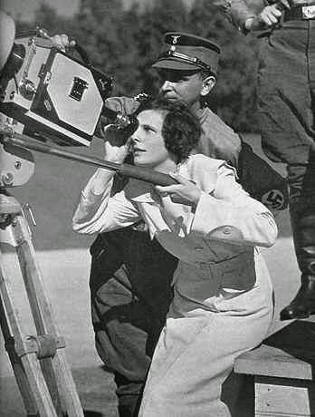Riefenstahl was often regarded to have an “impressive demon of strength”[7] by the way she overcame her battles against male colleagues and rivals and Olympia is clear evidence of this. Her documentary of the 1936 Olympics, Olympia, was praised as a successful film, which has since been widely recognised for its technical and visual achievements. It was this film which above all connotes her significance to the film industry as it was a turning point for Riefenstahl’s career due to the fact her film was highly praised by critics across the world, winning various awards such as National Film Prize (1937–1938). In 1960, the film was voted as one of the 10 best films of all time and was again praised in 2002 by The Daily Telegraph, recognizing Olympiaas “even more technically dazzling (if more stylised and less powerful) than Triumph of the Will.”[8] The source clearly shows Leni Riefenstahl to be significant to film culture as she was praised revolutionising film as we know it. By using a range of modern filming techniques, such as tracking shots of athletes and her impressive editing approach, Leni Riefenstahl shows her significance to the film industry as she reshaped how an audience reacted to film and thus paved the way for a more modern film age. This is further supported by the source as it suggests that Leni Riefenstahl was celebrated for her achievements as a director rather than a Nazi filmmaker as Olympia wasn’t regarded as a propagandist film in contrast to its predecessor’s. However, it could be argued that the Daily Telegraph is a right wing news paper and is shown to view Leni Riefenstahl’s work in a much more positive light due to its political content. Consequently, this proves the source to be unreliable as they contain an element of biasness.

During the Cold War period, Riefenstahl’s underwent a public renaissance, from the popular image of a culprit of the Nazi regime eventually manifesting into the new image of an unwitting, apolitical director. This shows people’s perception of her significance to the industry changing overtime, from the nazi sympathiser who created propaganda films to glorify Nazism to the ground-breaking female director who created breath taking pieces of art. A key example of her highly regarded apolitical works was Olympia. Olympia was viewed as one of the “great achievements of cinematic history”[9] with only few people viewing it as propaganda. Nevertheless, the film continued to cause controversy well into the 1970’s. In the 1972 Munich Summer Olympics, Olympia was shown at the Munich cinema and was considered a popular success. However, vigorous protests prevented its viewing in Berlin. This suggests that Riefenstahl’s contribution to film culture was significant as she continued to be a burgeoning influence upon the German people as she was still able to provoke a reaction from her audiences, years after her films prior release. It is this provocative aspect of her films which allows her to be significant to the film industry as it was her ability to create a brilliant stylisation which further produced a “tremendous aesthetic and technical cinematic achievement”.[10] While the newspaper is known for celebrating independent culture and further enforces the argument that Leni Riefenstahl was a significant figure within film culture, it could be argued that due to its right winged political allegiances, it is likely to be in favour of her films due to their political content. The source is also a media outlet which offers its own mediation of specific events thus rendering the source unreliable and therefore lowering her significance.

It could be argued that Leni Riefenstahl was only ever famous for being a Nazi filmmaker and consequently not significant to film culture. Her works before the rise of the Nazis such as The Blue Light have not gained nearly as much attention as her propaganda films. While on one hand, it is undeniable that Triumph of the Will and Olympia are outstanding films, their purpose for brainwashing is quite clearly shown throughout history; signifying that Leni Riefenstahl was truly was significant to the film industry. On the other hand film historian, Rainer Rother stated that “the way they are crafted is more convincing than any other art produced under the Nazi regime and as on propaganda on its behalf”[11] which argues that Riefenstahl’s propaganda films were not considered shocking or revolutionary until years after the war. This therefore shows that her contribution to film culture was neither revolutionary nor worthy to mention as part of film history. In contrast to this, the source also indicates that Leni Riefenstahl’s films were in fact significant to film culture as they were a much higher quality of propaganda in contrast to the other forms of film produced by the government. While the source illustrates her significance to film culture, it also implies that Riefenstahl was only great for having been the Nazi film maker she has always denied she ever was and indicates that she her significance to the film industry was highly overrated.

In 1998 the German band Rammstein used Riefenstahl’s footage of Olympia for the song “stripped”. The reaction they received for using Olympia shows Riefenstahl’s significance to the film industry as her footage still had the ability to gain a reaction from audience’s years after its initial release as many saw it as glorification of Nazism rather than a “expression good art rather than an endorsement of Nazism”[12]. The band themselves enforce the idea of her significance as they considered her work as a seductive and artistic master piece rather than a film by a Nazi sympathiser which subverts the idea that she gained her reputation as a significant figure head to modern film through her involvement within the Nazi regime. However, in spite of this, Rammstein are known to be a highly controversial band that is known to do things in order to cause a reaction. While her worked sparked a reaction from the Anti-Defamation League, it could simply be due to her association with the Nazis rather than her talent as a filmmaker; implying that she isn’t as significant as she has been made out to be.

Her first documentary Victory of Faith (1933) was significant to film culture as it was one of the first modern forms of propaganda in Germany. Film Historians such as Edward Buscombe and Rob White have argued that “For Riefenstahl, Victory of Faith was a dress rehearsal for her biggest challenge yet”[13] which firmly rooted her as “the Nazi filmmaker” and established her significance to the film industry supporting the ideology that Victory was simply a rehearsal film for other Nazi rallies. This idea is further enforced by the fact that after Victory, Hitler was hell bent on ending the distinction between reality and fiction; something which he and Riefenstahl achieved a year later in Triumph for which the entire rally was staged and scripted as well as the crowd being strictly controlled. In turn, this connotes Riefenstahl to be significant to film culture as it indicates that her talent as a film director was the catalyst for Nazi propaganda within Germany. Films such as Triumph and Tiefland shows Riefenstahl’s significance as they changed the way audiences experienced films and “would neither have caused a sensation at the time nor be considered classics today“[14]. This also conforms to the idea that Leni Riefenstahl’s films commonly associated with the Hypodermic Syringe Theory, which allowed the Nazi’s to control and manipulate audiences into their way of thinking. It was this method of control which caused Riefenstahl to become more significant to film culture in Germany as she, under the apparent orders of Hitler, was able to psychologically manipulate and control audiences into supporting the National Socialists but also unifying the nation.

David Thompson, a film historian argued that independent German cinema had a big influence on American film, stating that “German cultural tradition was more prepared to see identification [whereas] American cinema... catches fantasy appeal”.[15] Thompson suggests that Leni Riefenstahl’s significance within Film Culture doesn’t solely lie within Germany, but that her work was influential across the world. However, while she clearly made a vast contribution to film culture, not only in Germany, but across the globe, she is considered an extremely controversial figure due to her association with the Nazi’s. Despite this, Thompson fails to provide any other information about Leni Riefenstahl and her contribution to cinema. This connotes that Leni Riefenstahl her significance to film culture was highly exaggerated and thus showing that she is irrelevant. In contrast to this, Historian Rainer Rother, argues that “Riefenstahl was arguably the most famous women film director in the world” and therefore raises her significance to film culture as she still considered influential across the world years after her films initial release.

On one hand, Leni Riefenstahl is described as the “Valkyrie goddess of third Reich cinema”[16] which clearly indicates her significance within the film industry. This source could be problematic as it focuses mainly on her relationship with Hitler as opposed to her actual contribution to film. While it is argued that Riefenstahl was significant to film culture, she is shown to have “grown in popularity because of, not despite, the cliché of the Nazi film maker”[17]. As a result, this source lessens her significance as it implies that, had she refused to take part in creating propaganda for the Nazi’s, her contributions to the industry would not be as famous and as well known.

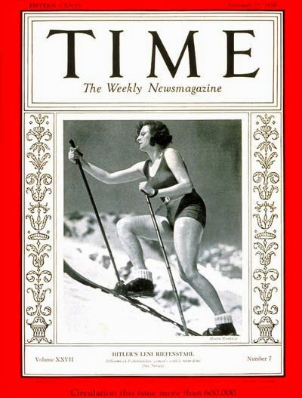Leni Riefenstahl is also shown to be significant to film culture as exhibits of her work were shown in a variety of cities across the globe such as Tokyo, Milan, Rome and Potsdam. This clearly connotes her significance to film culture as her work is still looked upon as notorious and influential years after its initial release. Her appearance in Time Magazine further connotes her significance to film culture as her appearance in one of America’s most powerful magazines indicates that she is still considered a powerful influence on film culture as we know. Furthermore, this indicates that Leni Riefenstahl was significant, not only to film culture within Germany, but also within the USA throughout time, proving that Riefenstahl is, in terms of popular culture of the 21st century, a cult artist and influential across time. Even in death, Leni Riefenstahl was celebrated as a talented filmmaker. A quote from The Daily Telegraph stated that she “was perhaps the most talented female cinema director of the 20th century”[18]. This shows that Riefenstahl continued to be a significant figure in modern film culture by the way she was celebrated for, not only her achievements, but also for the way she revolutionised technical and visual elements of film production.

While she is considered significant due to the way she modernised film and continued to provoke a reaction from audience’s years after their initial release, it could be argued that she is significant for tarnishing the film industry as a result of both the content of her films as well as her use of slave labour. Records from Marzahn detention camp indicate that “Sinti and Roma...were compelled to work as extras”[19] in her film Tiefland (1954) between 1940- 42. The source is taken from a survivor from the camp who worked on the set and is subsequently clear evidence that she is significant for tarnishing the film industry as she forced people to work against their will in order to complete her film. On closer inspection, it is worth considering that this evidence shows Riefenstahl not be as significant to the film industry as she would not have of been able to complete Tiefland if she had not been involved with the Nazi’s. This indicated that Riefenstahl is only famous for being the Nazi Filmmaker and that it was her films and her association with the regime which allowed her to establish her legend, thus only giving the illusion that she is significant to the film industry. It was later revealed that many of these workers were sent back to concentration camps where they were eventually killed. Consequently, this shows Riefenstahl to be significant to the film industry as her film tarnished its reputation as a form of escapism for people across the world. By using forced labour, she conformed to the Nazi stereotype with which she had been branded with for years after the war. However, it is this quality which allows her to further show her significance to the industry. Tiefland, while known for its horrific treatment of gypsies, has been argued by historians such as Robert von Dassanowsky that it has influenced of many Hollywood blockbusters, such as James Cameron’s Titanic through its similar narrative structure.[20] Had she have not been involved with the Nazi’s, she may not have gained the ‘additional help’ in time to create the film. As a result, this indicates Leni Riefenstahl to be significant to the film industry as her work became the influence for one of the biggest films in Hollywood.

In conclusion, Leni Riefenstahl was significant to the film industry during the period that she produced her films as she revolutionised modern techniques of filmmaking; changing the way we as an audience experience a film. However, she has also gained significance over and across time as her films are still considered technological masterpieces, continuing to provoke a reaction from their viewer’s years after their initial release. While taking this into consideration, many believe that she wasn’t the cinematic genius that her critics like to think she is and is therefore not significant to the film industry. Her association with the Nazis was her only claim to fame and the only reason she became so famous, had she have never filmed Nazi propaganda, I highly doubt she would have been as successful and admired over and across time.

[1] Leni Riefenstahl: Seduction of Genius- R Rother- 2002
[2] Leni Riefenstahl: Seduction of Genius- R Rother- 2002
[3] Leni Riefenstahl: A Life- J Trimborn- 2002
[4] Leni Riefenstahl: A Life- J Trimborn- 2002
[5] The Big Screen- D Thompson- 2012
[6] Hollywood and Hitler: 1933-1939- T Doherty- 2013
[7] T Doherty- Hollywood and Hitler: 1933-1939- 2013
[8] Leni Riefenstahl- The Daily Telegraph- 2002
[9] Leni Riefenstahl: Seduction of Genius- R Rother- 2002
[10] www.theguardian.com/film
[11] Leni Riefenstahl: Seduction of Genius- R Rother- 2002
[12] www.mtv.com/news/.../rammsteins-nazi-tainted-video-raises
[13] British Film Institute Film Classics- Buscombe, White- 2002
[14] http://www.learntoquestion.com/class/discussion/
[15] The Big Screen- D Thompson- 2012
[16] Hollywood and Hitler: 1933-1939- T Doherty- 2013
[17] Leni Riefenstahl: Seduction of Genius- R Rother- 2002
[18] www.telegraph.co.uk
[19] Historical Journal of Film, Radio and Television: Leni Riefenstahl’s Gypsy Question- S Tegel- 2003
[20] Cinema Journal: A Mountain of a Ship: Locating the "Bergfilm" in James Cameron's "Titanic"- R Von Dassanowsky- 2001

http://thathistorianjess.blogspot.com/2015/01/how-significant-was-leni-riefenstahl-to.html

